Architectural Models Network: Practitioner in Focus

Interview:

Interviewer: Margherita Manca (MA student, History of Design, V&A/RCA)
Interviewee: Henry Louth and Vishu Booshan Zaha Hadid Architects Computatation and Design Research Group (ZHCODE)
Date: 24 January 2019
Location: Victoria & Albert Museum

00:11 MM: It is Thursday 24th January 2019 at the Victoria & Albert Museum. My name is Margherita Manca and I have the pleasure to introduce Henry Louth and Vishu Bhooshan, both architects and computational designers at Zaha Hadid Architects in London and more specifically members of its Computation and Design research group. Thank you both for joining me.

So, I think the first question I'd like to ask you is what exactly computational design is and how you and your research group approach it?

00:45 HL: Have a go, Vishu.

00:48 VB: Ok. Thank you for inviting us. Computational design is a field in design where you are using computational algorithms and computational power to design. By that I mean algorithms we can refer to, we refer quite a lot to the computer graphics industry, the gaming industry etc., to develop the tools, but at the same time we are also interested in digital manufacturing technologies like robotics, 3D printing etc. So, computational design is a world, which is between these two fields— using computer graphics and algorithms to improve your design, which can be made more feasible, informed with structure, which can be informed with fabrication technologies, which are persistent and then making a more informed architectural model or architectural design. So, that is what I would think constitutes computational design or computational architectural modelling.

01:55 HL: I would just add to that what's different when I look at the architectural field today is what computational design, at least for me is now, it is a chance to use the toolset of the time of the contemporary possible toolsets. So, if we were to look at what was utility is a hundred years back that would be very different than utility that is possible today. And so, if now we have the ever-increasing possibility of using computers to do innumerable things, we have that as a tool. So architecturally, it is sort of our obligation in the field to see how we can integrate such a thing into our workflow. And so, what we've done is started to explore how we can use not just computational power to accelerate things, which obviously could be done —to transpose— what's already been done in CAD, drafting to digital drawings, right? But it’s more about trying to use that power to take us in places that we were maybe not able to see before. This gets into the realm of artificial intelligence and actually predictive behaviours, but also just trying to explore design space that otherwise might have been difficult to visualise or examine.

A simple example of this is using simulated physics to approximate how the world behaves around us. And so, in our group we are constantly exploring ways to form find, to use a term Frei Otto uses a lot, to develop design solutions or design spaces that we could maybe not draw by hand (Figure 01).

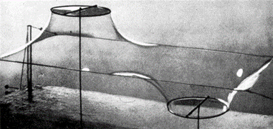
[Figure 01 - Frei Otto physical form finding using soap films model. (Image Credit: Frei, Otto, and Bodo Rasch. "Finding Form: towards an architecture of the minimal." Axel Menges, Stuttgard (1995)]

And that’s not to say that we couldn't draw them by hand, it is to say that perhaps I could explore ten solutions in the amount of time that it, I could only draft it once. That's one way to think about it.

Another is to say that as we increase complexity in how we create a shape or generate a geometry I can then control many variants of that or ways of morphing that in a way that I could not do by hand as expeditiously before or as varied before. So, we're using a tool now to develop design solutions that otherwise may not have been explorable in a given amount of time. And so, it in a sense frees up the designer to think more loosely about where things could go, to question more critically about; what if? What if that? And it offers us more chance for different design space, more varied design space, more localised design space and a more contextualised design space.

So, at least for me it’s more of utilising the tools of the day to produce something that is relevant contextually today in a way that our predecessors were putting onus on technology to construct some masonry vaults, for instance. So, that’s where it is, it’s less of a term for me and more about trying to make relevant what are the innovations in today’s toolsets or skill-sets.

05:44 VB: Yes, and I think it has also made these tools very accessible to different sets of, like a lot of architects. Previously, to take the example of Antonio Gaudi, it was like a master engineer/architect who did this kinds of physical form finding and it was very relevant to only him, only he could do it, kind of thing (Figure 02).

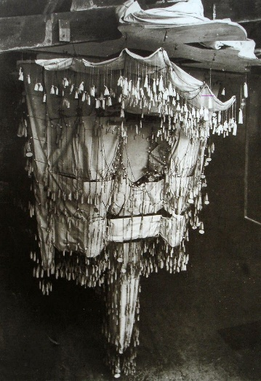

[Figure 02 - Antonio Gaudi physical form finding using inverted hanging chain model. (Image Credit: Huerta, Santiago. "Structural design in the work of Gaudi." Architectural science review 49.4 (2006): 324-339)]
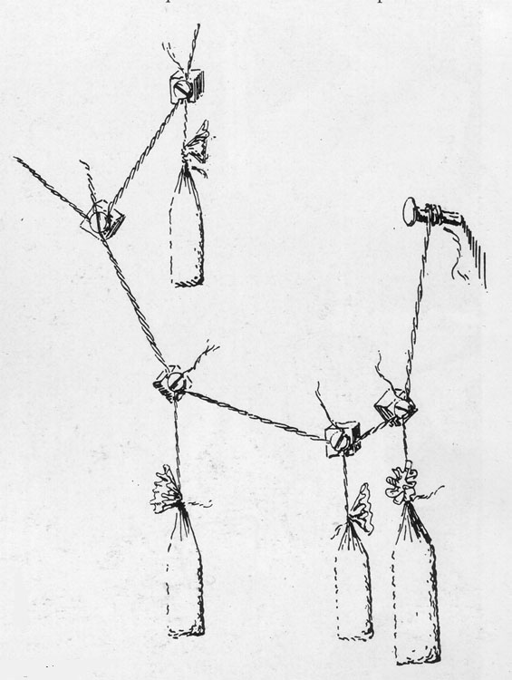

[Figure 2A – Antonio Gaudi (Image Credit: Maher, A., Burry, M. (2003). The Parametric Bridge: Connecting Digital Design Techniques in Architecture and Engineering. In: Proceedings of the 2003 Annual Conference of the Association for Computer Aided Design in Architecture. Ball State University, Indianapolis, USA, Oct. 23-26, 2003, pp. 39-47.)]

But now that these tools have become more digitized and lot more people can use them. So, these tools are making architectural design which performs at multiple layers like structure and fabrication more feasible, which were previously only explored by master architects or master builders who had that knowledge.

06:32 MM: Yes, thank you both. It is interesting that you bring in this historical aspect and I wanted to ask you - can you remember a time when you didn't have access to the level of advanced technology that you have now? So, for example - has your use of computational design change over the course of your career? Has it changed very rapidly or how has that progressed within your work over the last few years?

06:58 VB: So, the field itself is quite in its infancy. I would say it has developed rapidly over the last two decades and we can see a lot of difference in how the technology was ten years ago and how it is now, like it has progressed. The use of computation in design has progressed quite rapidly I would say over the last fifteen to twenty years, so you can see, actually see it in the designs. You can actually make out what was designed in the early 2000s and what is designed now.

07:32 MM: Right, and so if we move on to the models that you guys use in your work. That change [in technology] is also visible in those, I wonder?

07:44 HL: Definitely. So, the way that we think about 'model' is a bit loose in the sense that a model is a tool for us to examine some feature or some tectonic aspect of our design. And I mean that's a super loose definition, but it’s a tool, it’s not a representation. So, when we make a model, we don't intend to make a final product. We are trying to question ourselves and to point something out that we can then discuss critically. And it’s never really final; it’s sort of a stepping stone, either for that particular research strand or just to freeze where we are at that moment in time.

08:38 So, I'll back track a second here. So, when we think about the word 'tool', it's actually a little more apparent for us what 'model' is.

So, like earlier ways where we think about tool and utility in general, and the making of things, we use this example of Brunelleschi and the dome often, which is on screen here and I can send it to you later (Figure 03).
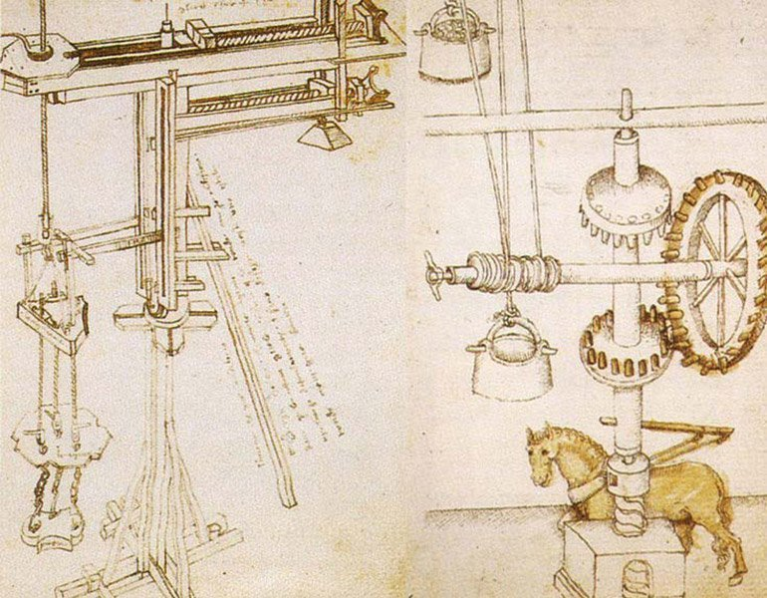
[Figure 03 – Filippo Brunelleschi sketches of machines for hoisting as utilised for Duomo (Image Credit: Innocenzi P. (2019) Cupolas and Machines. In: The Innovators Behind Leonardo. Springer, Cham)]

But the idea is that the making of the dome itself was innovative, but the fact is that to create the dome, you had to make the tool that would allow you to lift all of the masonry stones into place, which actually meant creating this cog wheel that would allow the horse to only go in one direction instead of having him back-up to send it back down, which seems very simple, right? It's a simple problem, I need the horse to only go in one direction, but that tool was instrumental in the creation of the dome. That doesn't seem very advanced to us now, but that was incredibly advanced in the creation of the dome. It’s why we were able to get this.

So, our group is also engaged in the making of tools. So, is that a model? Perhaps. Is that a tool? Yes. Is it a stepping stone in the process? Yes. Is it remembered in part of the final construction? Its memory is sort of tied to how we document it, for sure, but without that tool, the dome would not exist.

And so, we look at models in sort of the same way. They are tools or utilities to start to make steps towards what is something else. So sometimes we'll make models that are physical. We will try and test out the elasticity of something or panelling of something or try to create a certain shape that abides by a certain physical property, geometrical property. But sometimes we're making digital models, simulation models that try to capture the physics of something. And this happens on a day-to-day basis in our group, that we often are abstracting information down to where there are points and lines in trying to make them do certain things as a tool that allows us to integrate it into a fabrication logic. Like, can it be unrolled and then cut from a machine, perhaps. Or, can it be used to actually simulate another behaviour?

11:09 So, Vishu has a book that will mention something just across the road here at the Science Museum where we're exploring simulated physics and relaxation of meshes to develop minimal surface topologies in the creation of these soap-bubble-like films that become the centrepieces around the turbulence field of the aircraft that's in this particular one. So, the tool that was created or the model in this, is actually a simulated physics model of where all of these vectoral directions of flow might go (Figure 04).

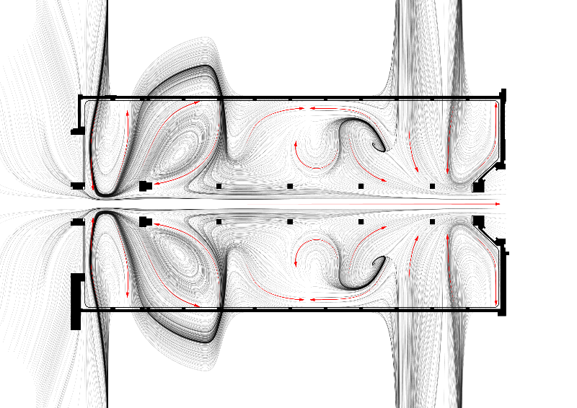
[Figure 04 – Science Museum Maths Gallery simulated physics vector flow field tool (Image Credit: Zaha Hadid Architects)]

And then downstream of that we start to derive entities or actual manifested objects. In this case, there's a minimal surface- like object. If you go down to the floor level, it’s actually the patterning that starts to take on the properties of this physics flow field (Figure 05) and then other things as well: the direction of all the panels (Figure 06), the actual benches that align to them (Figure 07).

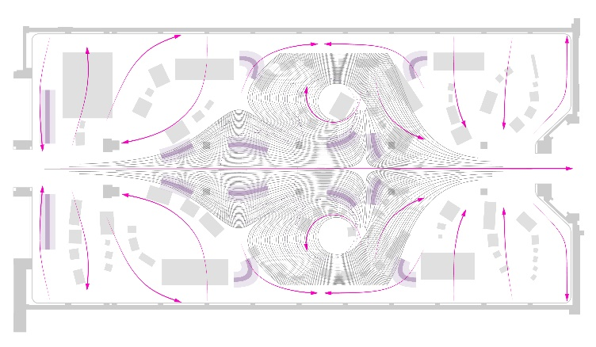
[Figure 05 – Science Museum Maths Gallery flooring pattern resulting instance from field (Image Credit: Zaha Hadid Architects)]

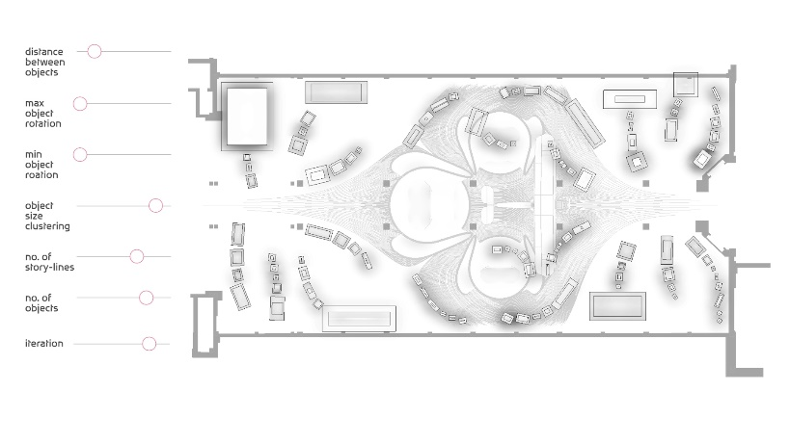

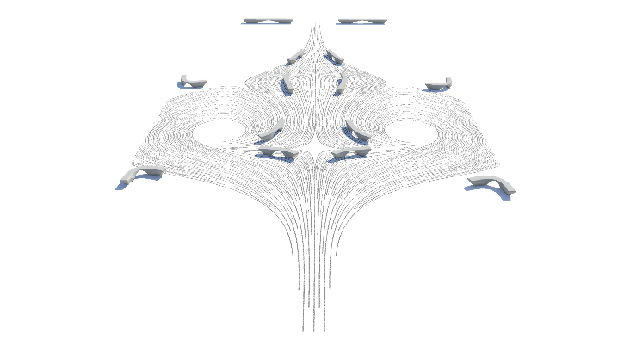
[Figure 06 – Science Museum Maths Gallery curatorial object displays positions from field (Image Credit: Zaha Hadid Architects)]
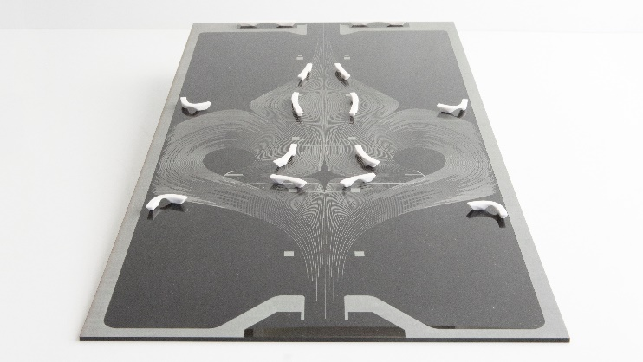
[Figure 07 – Science Museum Maths Gallery bench positions on curves from field
(Image Credit: Zaha Hadid Architects)]

So, all of these things are sort of manifesting this global ‘model’ in different ways. And this tool—of how we arrange a flow field—is downstream of that or is upstream of that I should say. And that is ultimately the ‘model’. When we think of model-making, all of the effort went into making how that flow field is arranged. So, when the flow field changes, if we divert it off in this direction all of these things sort of reorient, re-arrange to that. They acknowledge that the upper tool has changed, and therefore all of the downstream elements now sort of readjust.

12:51 VB: Just to highlight the focus of the group here, it’s like when we say an architectural model or architectural geometry, we say it’s not only a designed shape, but the shape which is informed with structure and fabrication.

So, taking the example of the Science Museum here, it was kind of, we knew it was going to be fabricated with fabric and metal edge beam, so here the model was integrated with constraints to make all of these pipes 2D or it needs to be made in fabric patches, right (Figure 08).
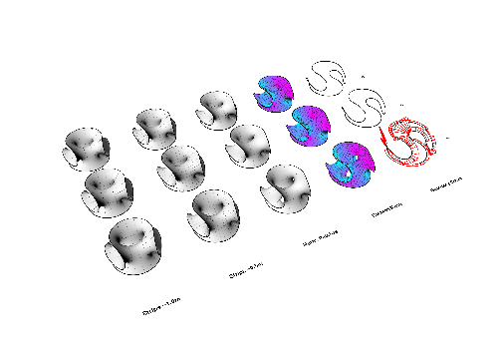

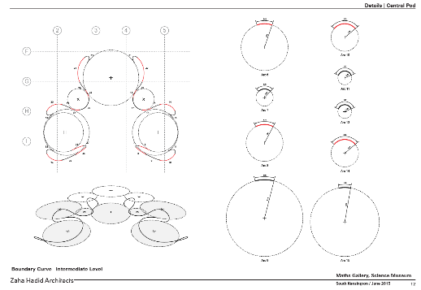

[Figure 08 – Science Museum Maths Gallery Pod Rationalisation Boundary and Fabric Seaming Elements (Image Credit: Zaha Hadid Architects)]

So, these constraints were already incorporated into a digital architectural model and then, as a proof of concept, we did a physical one. One is to fine model to prove that it can actually be done (Figure 09). So, even this is also a model for us. So, it could also be like some other example like here, these kinds of sculptures (Figure 39).
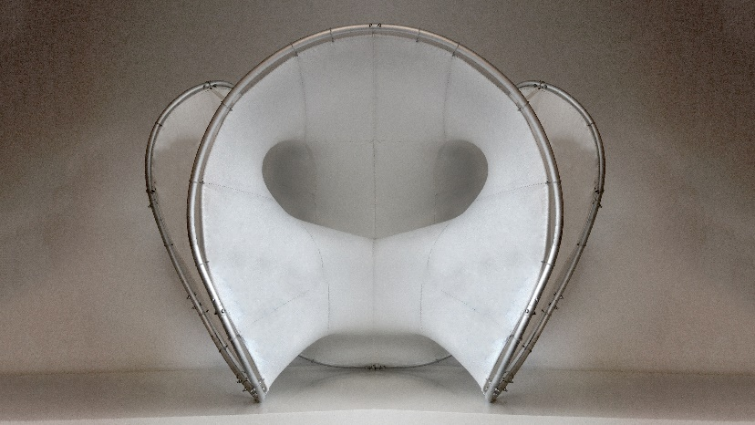
[Figure 09 – Science Museum Maths Gallery Physical Model Fabrication Proof of Concept (Image Credit: Zaha Hadid Architects)]

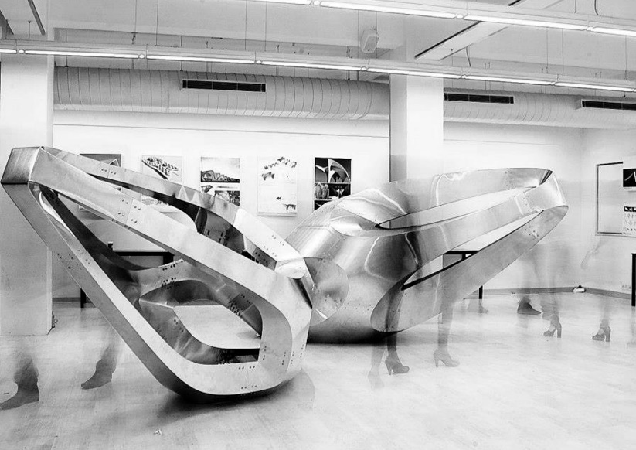
[Figure – 39 ZHA and AA Visiting School Bangalore Curve Crease Folded Sculpture 2012 (Image Credit: Shankar Ramakrishanan)]

These I would also call models for us because it’s like a prototype. So, we are trying to investigate some aspects of fabrication here, which is cutting 2D sheets and bending them into the shape. So, this is a proof of concept model for that kind of fabrication methodology where you are trying to make a model unroll into flat sheets and then bending it back in the physical space. So, this is also a model or a proof of concept, which can then be applied into an architectural scale design when we are building housing, for example.

So, we have models at varying scales, it can be digital, physical, but all of them are exploring the aspects of: it has to be actually structurally feasible and it has to be actually made physically. So, these are kind of primary constraints, which we use in our design and development of the model itself.

14:46 HL: Yes, well here the term 'demonstrator' is used a lot in the discipline, or 'prototype' is used a lot in the discipline. And 'prototype' is maybe a little more apt term for how we think about model because ‘model’ is very much still a work in progress for us, an exploratory process. It’s not a representation. Yes, we do make representational models. You know, clients want models. They're very useful marketing tools for sure, and we have them on exhibition, no problem. But our group is more engaged in trying to make things that pose problems for people to examine, you know? Or to evoke other questions that perhaps need to be solved and Vishu’s pointed out some very good ones here. Maybe as we go on with the questions I'm sure some of the teaching focus will come up and how this comes into play with model making and feedback in the profession.

15:42 MM: Yeah, if I can pick up on the sort of, I guess the work-in-progress aspect that you guys have mentioned, of the model which I think is very interesting and differs to the traditional content of the model. How does the materiality of it, and the different materials used, how is that determined? And so, for example, if you initially have a digital model that is then made physically - do you try that in several different materials or what is the kind of process for the actual tangible materials used?

16:15 VB: So, in the initial stages we might not have a material in mind, but we might have like a fabrication constraint in mind. Let's say, it needs to be made up of flat sheet material, which is cut and then folded into place. This flat sheet can be materialised differently; it could be flat sheets of metal or it could be flat sheets of plywood. So, there are different types to explore it, but the computational model is the same in the sense that each of the geometries we have has to unroll into flat sheets So that is the geometrical constraint of the fabrication. Then we can explore the fabrication in multiple different materials. In this case, timber or metal or if it is becoming a minimal surface, like in the case of in the Science Museum, then in that case we knew it was going to be done in fabric, so that's why it had to be minimal surface because, it then only can make it out of fabric. So, it kind of goes both ways - one is to kind of abstract it geometrically, so you can visualise it in the 3D world in the computer, and the other one is also informed through physical ways of doing things.

17:40 HL: Yes and so, what I think Vishu is starting to touch on, I'm going to talk about Volu here for a second (Figure 10,11).
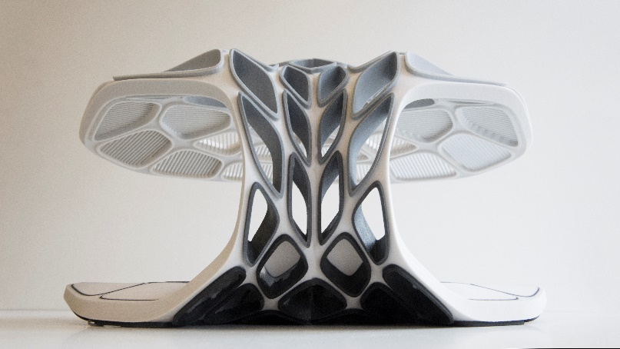

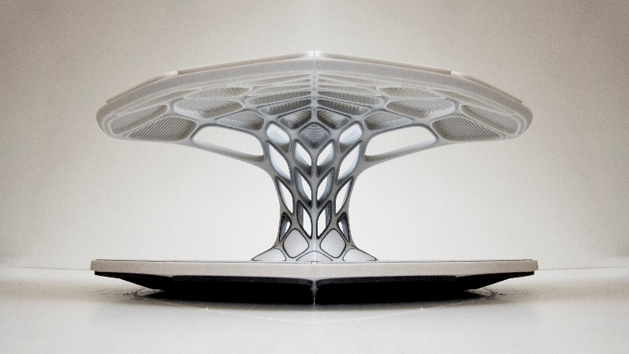

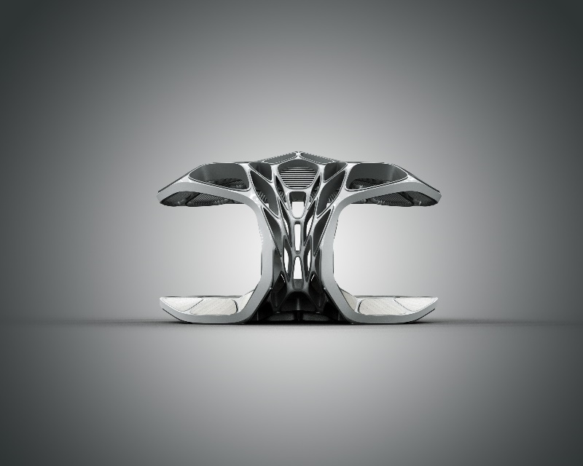
[Figure 10 – Volu General Render and 3D Prints (Image Credit: Zaha Hadid Architects)]

VIDEO
[Figure 11 – Volu Overview Video (Video Credit: Zaha Hadid Architects)]

Volu is prefabricated dining pavilion that we've done in 2015 for Miami Art Basel, but the way that we developed this particular project was to develop a pattern that was responsive to the structural demands of this sort of cantilever clam shell and that optimization—it’s called topology optimization—it seeks to remove material where it is not needed (Figure 12).

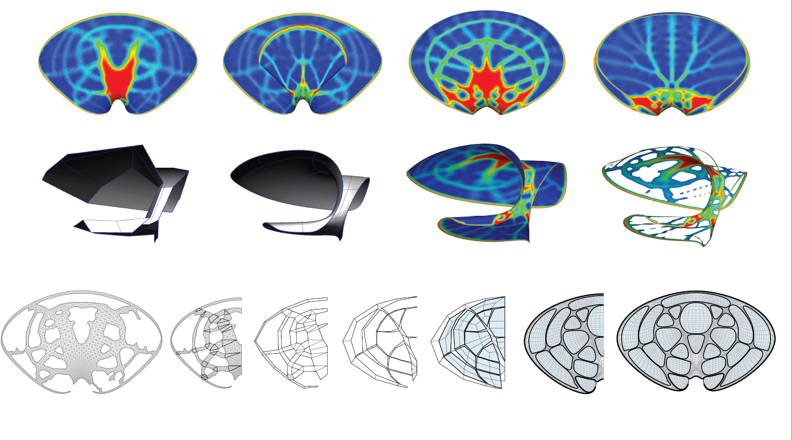
[Figure 12 – Volu Topology Optimisation Pattern (Image Credit: Zaha Hadid Architects)]

So, if you think about that, it just sort of gives us a generic pattern, if it were. There is no thickness, no inherent material. You asked about material and fabrication. So, then we're left with, OK, you know, we have this pattern, but we have to make this thing and we, you know, in many ways we can make it. So, we ask ourselves what if? This question comes up all the time. So, if we take this generic pattern and we were to make it out of a grid shell of just two flat sheets, how would that change the primary beam pattern, bending pattern? Then we say: “OK, what if we rotate the orientation, so the axis is different, right?” Then that has a different demand that allows us to do different possibilities. So, the underlying patterning, and we call it topology, is the same, but we explore that space in a very fabrication driven logic.

So, this expands in some other ways. So, if we do bent pipe and they all sort of bundle together, how would that pattern play out? If we did it as a uniform box beam that are sort of clad with curved pieces, what would that look like? So, there is a range on the same generic type topology that have very specific fabrication restraints overlaid on each one (Figure 13).
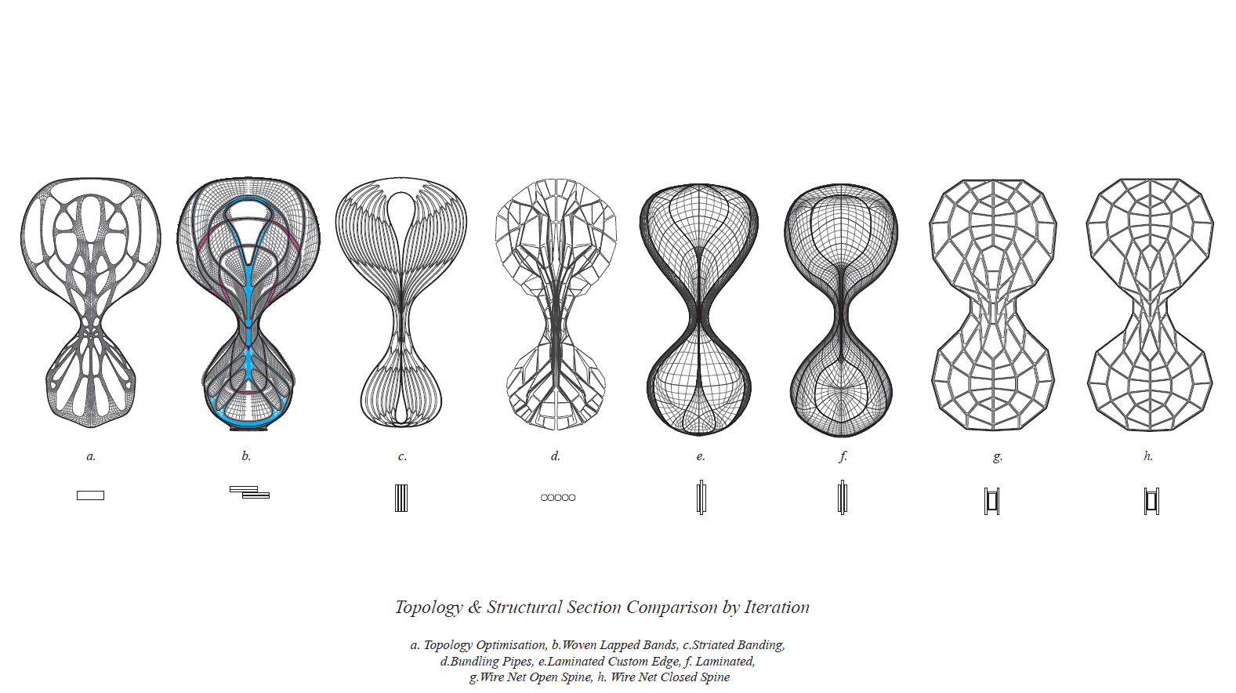

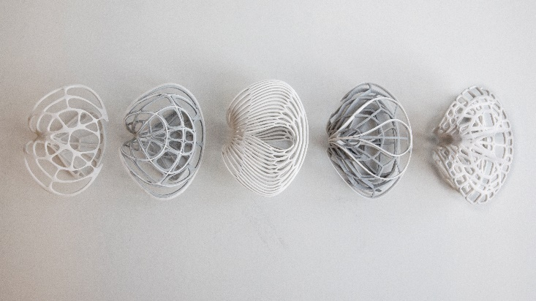
[Figure 13 – Volu Architectural Implications of Fabricated Cross Section on Pattern and 3D Prints (Image Credit: Zaha Hadid Architects)]

And so, we develop models to basically explore that, right, and this is if we didn’t care and could 3D print it, it would just be this skeleton that has no differentiation whatsoever. But that's not the world we live in, right?

These are much closer to the world we live in. Something that's tied to a specific fabrication, a specific material orientation, whether its elastic or not, deformable or not, so those start to play out. So, we don't just stop necessarily at like the generic patterning of what something may be. I use generic loosely as well. I mean the structural patterning of this is inherent to the shape of it. But, we take it a step further like you said, and fabrication, how does that play in to how it’s manifested, and this is a very good example of that. The pattern could be very different if we made it out of wood, metal, bent pipe, etc.

20:32 VB: Yeah, I think it’s quite important for us as a group to kind of depict in the design how it is going to be manufactured; if it going to be 3D printed, it would have a different aesthetic; if it is going to be done with robots, it’s going to have a different aesthetic. So, it should be evident from looking at the model, how it is manufactured and that's one of the primary goals within the group, to say “OK, if this is to 3D printed how would we look at the design of it? If it is done with industrial robots, how would it look differently? So, if it is done with flat sheet material, like the one here, how would it look differently?” (Figure 14)

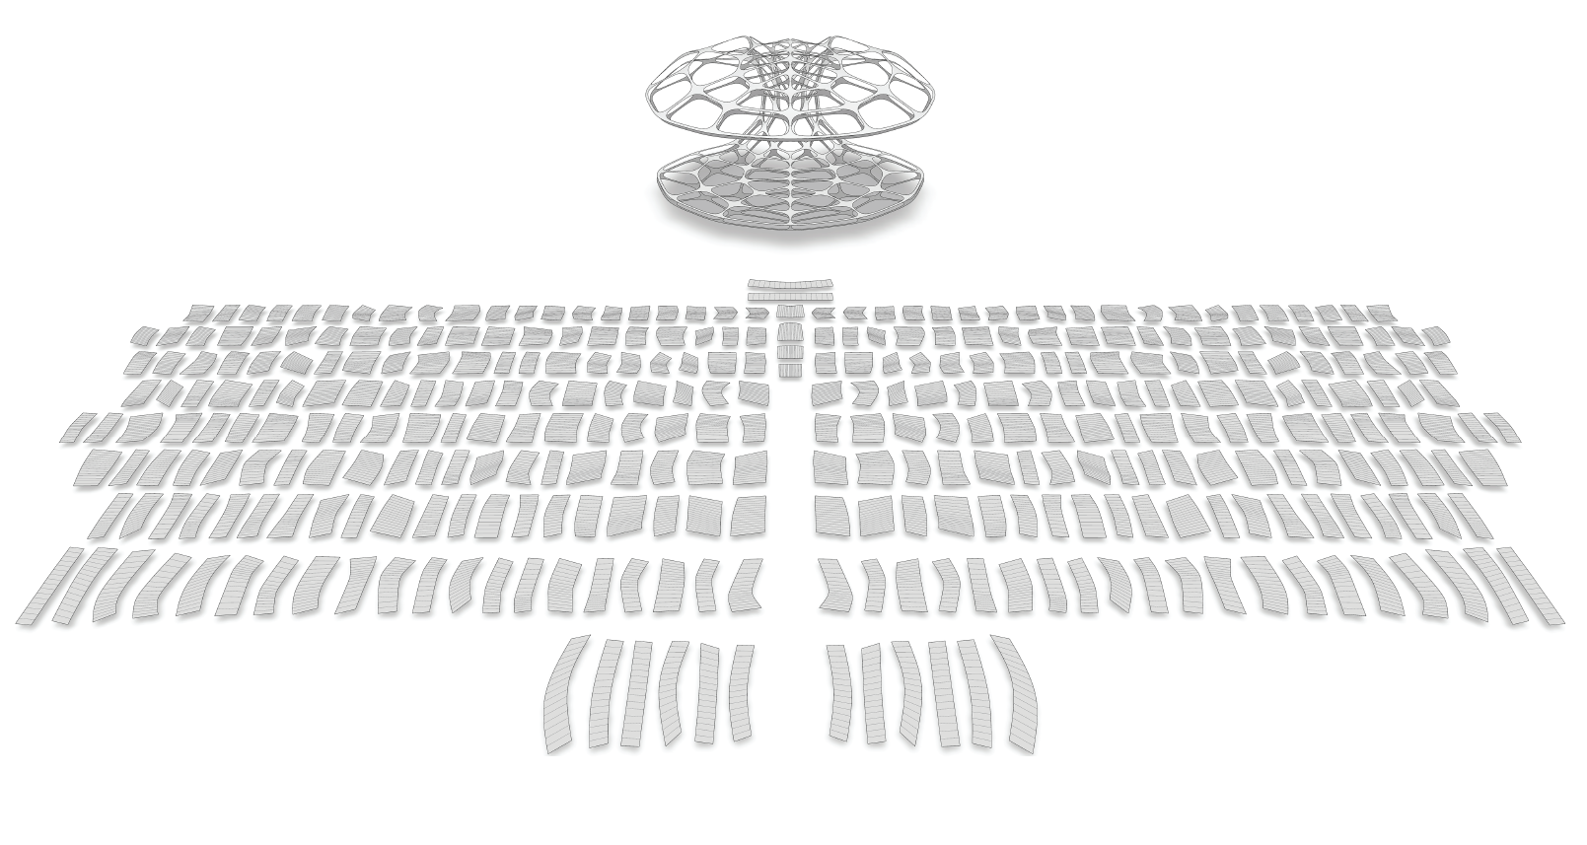
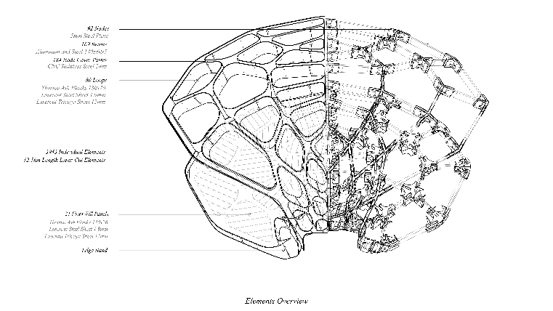
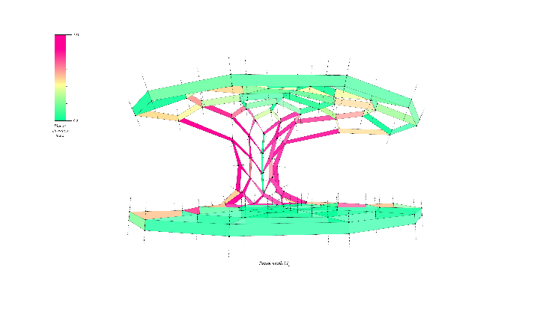
[Figure 14 – Volu Beam Net Simulation Model, Assemblies Overview, and unroll patterns, (Image Credit: Zaha Hadid Architects)]

21:14 HL: We are trying very specifically to get the fabrication to relate to the geometry so that it could only be made that way. But, there's a specificity about its construction that is not lost when you look at this thing. And this also captures a sense of its time, like in contemporary construction: could this have been made 10 years ago? Would it be made 10 years from now? Would we make it differently with different tools? Whether they are advanced or not is really not something that is of utmost concern to us. What is important is exploring the possibilities of today. And when we talk about the visiting schools and teaching in general, often that comes down to very fundamental practices of making and just building up complex behaviour from something very simple. That's not necessarily advanced but becomes complex in how it is either assembled or put together, or put together or something else that lends itself towards being advance looking, but not advanced, right?

22:37 VB: Yes, going back, if I can just add, going back to your previous question of you asked how technology has changed over the last ten years or so. So, the paradigm of how architectural geometry is viewed has actually changed in the sense that if this was done ten years ago there would be the design of a shape and then once you think of fabrication you rationalise the geometry to be made using that specific way of fabrication. But the paradigm now, what we have seen in architectural design, is we incorporate these logics of structure and fabrication at the beginning of the design (Figure 15), so we don't have any complications or surprises later on, so we already have an understanding of how it’s going to be made and how it’s going to stand. So, that's like a shift in paradigm, which has been allowed because of technology and improvements in computation.

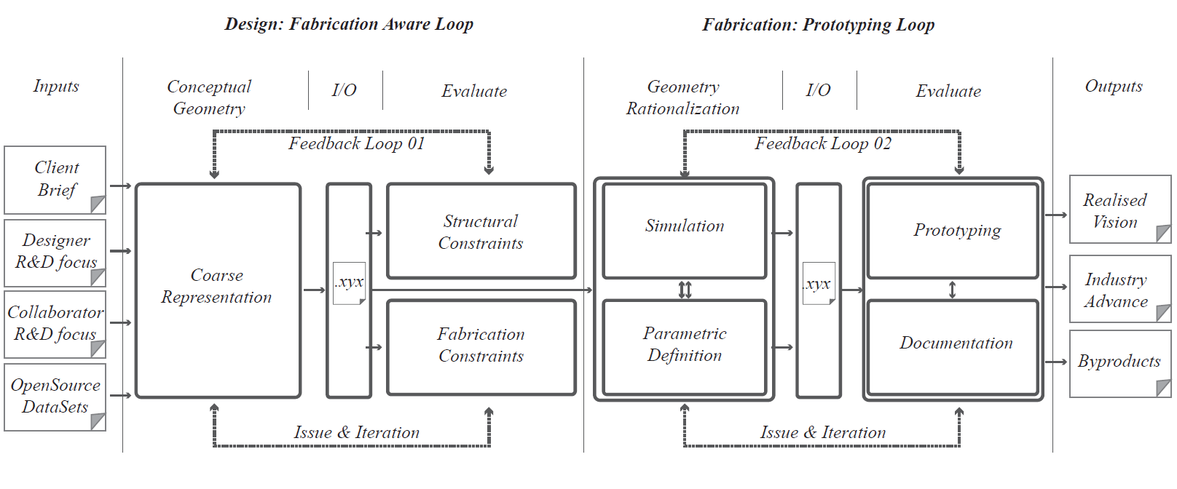
[Figure 15 – ZHA CODE Structural and fabrication aware geometry workflow
(Image Credit: Zaha Hadid Architects)]

23:30 MM: Thank you, that's really fascinating. I would like to pick up on the fact that you talked a lot about the fabrication and the behind the scenes and how it’s all made and produced, but you've also talked about the world we live in with regards to Volu, and I wonder to what extent you guys who are obviously from a very technology heavy background consider the audience and the people who are observing either your final product or even the way that your clients will interact with your models? So, sort of the non-makers and non-designers, how are they factored in to the work you do, if at all?

24:12 VB: That's, again, new areas of investigations that are happening now to see kind of, integrate the user experience into how we design. So, for example, in some of the animations of the Science Museum (Figure 16), not this one, you can see we wanted to integrate how people navigate in the gallery.

VIDEO
[Figure 16 – Science Museum Maths Gallery Video (Video Credit: Zaha Hadid Architects)]

So, the basic brief was to have more people interact with the objects in the gallery than just walk through the gallery. So, we kind of integrated those things also into the design of the space itself. So, we wanted them to actually spend more time in the gallery looking at the different objects and so that is something that is getting added onto the design space now. So, as I said previously, it was structure and fabrication constraints, but now we are also starting to add user experience into the early design stage, so we know we want, OK.
Let's say in this case they wanted people to spend more time in the galleries and how can we integrate that as a design parameter. We wanted to see a lot more objects in the space, so there is gradient of object sizes - you can see closer to the aisle are smaller objects and towards the wall are bigger objects, so people get to see a lot more of the objects at first grasp and whatever captures their attention they can go into that. So, if we can just slide it to a later part of the...keep going.
HL: Right around here.

25:56 So as you can see here, this is what we call user parametrics (Figure 17).

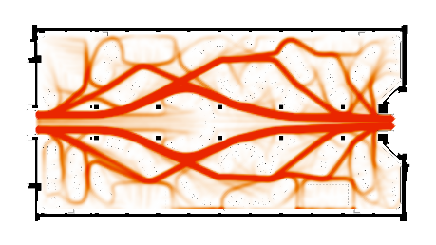
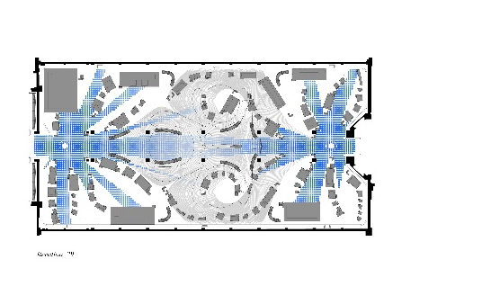
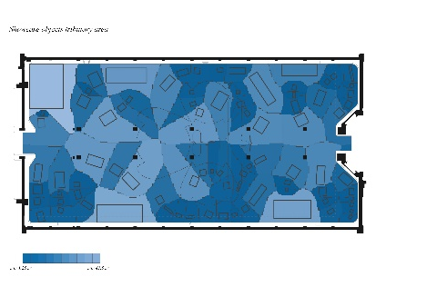
[Figure 17 – Science Museum Maths Gallery User parametrics, traffic, and visibility (Image Credit: Zaha Hadid Architects)]

So, this is looking at how much of it is visible and while you are walking how much of it is visible. So, these are parameters that are getting integrated into the design now. As an experiment the office [Zaha Hadid Architects] also has put sensors in our lobby to see how people congregate based on the furniture level. So, if the furniture positions changes, will they aggregate in X position, if the furniture is different they'll aggregate in some other position. So, this is in early stage research now, but it is slowly starting to get integrated into how we design spaces itself.

26:40 HL: If you think about why we are concerned with this now, it’s not just about ‘Why?’ but also about, ‘It is possible because we can compute it now’. The amount of data that you can have access to or generate during the course of the day even on just the furniture layout of our lobby is a good example, our office environment, your ability to collect that, collate that, regenerate that in a way that is then digestible by some type of model, computed model, is rapid now. And you can't imagine doing all four of those steps twenty years back, whereas today we can do them on our phones. And it’s a very different time to be able to access, manipulate and reuse data to do something. Whether we're using it to configure furniture or using it to regenerate geometry or using it to distribute space a certain way. I mean, the ability to do that, is now. And you know, data is a ‘model’ in and of itself.

The manipulation of data and how you do that, the algorithms that do that, the intelligence behind it, is in itself a model. Yes, it’s a bit of an abstract ‘model’, but it is something that has been authored to some regard and it is creating an output. And that output is probably more data but, you know, this was not possible before and we integrate data in absolutely everything. And our models sometimes just come down to a massive Excel spreadsheet of stuff. And would our predecessors have made buildings this way? They might have produced a schedule at the end which had a massive amount of data for takeoffs and such, but as an input to expect an architect to sort of be making geometry out of a massive spreadsheet is a bit abstract.

And this is something that we do, it’s part of our group. I don't even know how many cells the Science Museum had, but it was incredible. And this is how we operate now. Or at least computationally we have the ability to do this and we don't have to read every field. I just know they're there and if the fields are valid, it passes and then we author how it manipulates the fields to do XYZ. This is a very different world than just making geometry.

29:34 VB: The interesting bit there is how fusing data and into our computational workflow has brought a lot of stakeholders and architectural design process much closer. So, we can collaborate with the client who is able to feedback much more, like in the example of the Science Museum they were able to update their list of objects (Figure 18) which go into the space almost every week, they kept changing, and we had to adapt our design (Figure 19).

[Figure 18 – Science Museum Maths Gallery curatorial object database as design input (Image Credit: Zaha Hadid Architects)]

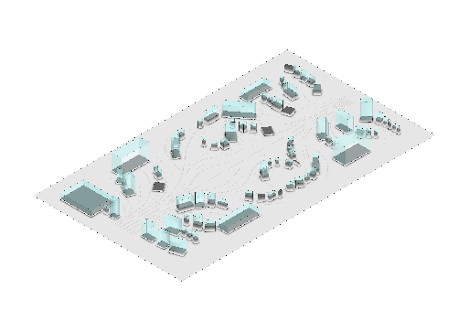
[Figure 19 – Science Museum Maths Gallery curatorial object output from database
(Image Credit: Zaha Hadid Architects)]

30:03 MM: Based on the data?

30:05 VB: Based on the data. Yes, so they were also part of the design process and they kept evolving their object list. Sometimes they changed their list based on how even we were designing and the other way around as well. But also bringing other stakeholders like fabricators because they also use the same language of computation and using the same toolkits, they can be integrated much earlier. So, the design workflow now is much more collaborative with all of these aspects considered than a linear process of the architect designs the shape, then it goes to the structural engineer, then it goes to the fabricator. It is no more a linear process, it’s all back and forth between all the collaborators.

30:49 MM: Great. So maybe we can pick up on this notion of collaboration to move onto the teaching aspect, Henry, and how the data and the models that you use, how do they come into the way that you teach the discipline? And are students collaborating with you in a certain way or do you find its more of a kind of didactic approach? I'm interested in how you convey your discipline to them.

31:23 HL: So, I'll step back from that for a second and then come right back to it. As a research group, Patrick has set up earlier the DRL (Design Research Laboratory) here in London at the AA school (Architectural Association) as sort of a way to explore computational design, design research as a practice in itself. And that, for the profession, has been broad-reaching. At least here in London we see how it’s been infused with a number of practices.

And that sort of way of thinking, that it’s not just about the practice itself, but how you feed into academia as a practitioner, that back and forth, is something which at Zaha as well they were just very keen on. And they understood and continue to understand how academia feeds energy and ideas and just how to develop in a way that may not be immediately possible within practice. So, I would say our group is an outlier, right, most architectural practices do not have research groups within them. And so, we operate a little bit differently.

But for those that don’t have a research practice, having an academic research arm to sort of help and draw resources upon is very useful, for whatever reason you might want.

33:14: But our role with academia has always been to either try and push either computation or fabrication or something, and so often when students come in, and I'll also use my own experience as a student, you know, they come from all walks of life, like all over.

I remember my first day at the AA, someone didn't have a mouse, they were expecting to use the track pad, and so the expectation that you come in and that you'll go out like as a computational designer isn't necessarily it. But you come in with the expectation that you'll be exposed to something. And sometimes that is what you bring to the table, like I was more interested in fabrication for instance and others its more computational, they want to, you know, develop data and algorithms and sort of artificial intelligence type things and that's fine. So, you get a full gamut. But what that means is that you have the opportunity at least in the model making side of things to explore things that would seem very elementary in one sense, but also very advance in another. So, when I started at the AA, we had two workshops which were very material based, and the first one was curved folding, so developing furniture out of sheet products that were all just bent (Figure 20).

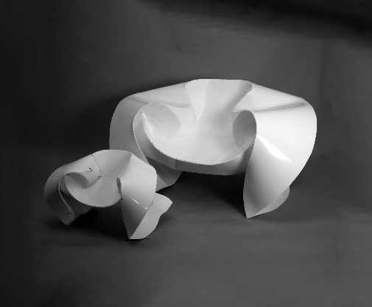
[Figure 20 – Architectural Association Design Research Lab 2012 Curved Crease Folded Rocking Chair prototypes 1:1 & 1:2 (Image Credit: Zaha Hadid Architects)]

And so, we just spent a few weeks bending paper by hand, folding paper by hand, over and over and over again and you make something out of it. And if you don't have a lot of experience with a computer as of yet, or at least some of the programming, or anything, its fine. The exploration of finding form, developing shape, exploring geometry, its relationship to the material world, is still very relevant and continues to be relevant for us today in the group. But it allows for an entry level to both material, model-making and computation to where the next stage, once you're exposed to particular materials or behaviours, etc., you then explore that same thing in a computed manner. So, what if I actually fold this digitally, like I try to fold this surface. And now I do it where I can actually relax it or unfold it, right, with simulated physics. So now I have the ability to fold something, digitally, see the unfolded version of it, digitally, and CNC mill it.
The first week as a student all you know how to do is fold it, but you've sort of gone full circle, so you see a little bit of each. So, all I'm trying to point out here is that students get exposed to the same sort of tools that they are exposed to computationally but also materially. And this is because we don't want to spend all of our time in a computer and never build anything. We live in the real world, we want to make real things. So, we ask them to make real things, sometimes first, sometimes we ask them to make computed things first, it just depends on sort of how they approach it. But they always have to do the other thing too, right. If you do the computed thing, you also have to make something, or if you make something, now we have to figure out how to compute it.

Sometimes it comes down to the group, and you have people who are naturally attuned to certain things. But that exposure to different parts of design is invaluable. And its exploratory, it’s almost like, my wife says, like a Montessori school, like it’s exploring by doing. And we keep that with us in the computation group, we explore by doing, sometimes digitally, sometimes physically. It depends on the times and when we're doing exhibitions sometimes we're doing more physical things. But if we're not doing an exhibition we may be doing a lot of digital things and then when something comes along, all of a sudden, we do a physical thing. Because we've developed that knowledge in the digital to produce the physical thing. So that's a lot of different aspects, but academia has allowed us to explore certain research strands as well and I think Vishu can talk more specifically about these and how we've developed the robotics as well. It’s just to say that academically, what's so different about our research group with academia in general as a research body is that it feeds back in a certain amount of energy and exploratory endeavours into a day to day that could otherwise not work open ended.

Our research sometimes has trajectories, but it doesn’t have a specific objective in mind, whereas a project has a definite objective in mind. So, we sort of already know when we're given a project it could go to XYZ. But because we have this research of different directions whether its robotics, data, different geometry, form finding, we have the potential to take it in different places because we've already done a certain amount of due diligence on robotics, for instance, or 3D printing to where we could call somebody up and take it down this road, we would feel comfortable with that, right? And some of that has been developed with an academic arm in mind, some of it is because graduates have joined us with specific sort of concentrations that they want to continue. But it continues to feed the energy and the trajectories that we pursue.

39:20 MM: I think that the co-existence of both the digital and the material is a really important aspect that it's sort of good to hear that both co-exist in a time where, like you're saying, technology is advancing so fast, that one of them isn't disappearing. And quite the opposite in fact, it remains quite useful at least in a certain part of the process. Now, one of the questions that I also wanted to ask, which is specific to model-making, but I'm interested in your perspective because of the fact that it’s such a work in progress tool. What are the challenges and the issues that you guys have found during the process of making? Is the fact in itself that it’s a tool, does that pose any problems? The fact that it can at any time be changed or what do you think?

40:19 VB: So, as we said, these types of prototypes, of demonstrative things are actually that if the model fails, it fails. So, we try to learn from that and improve the next time. So that's one of the things why we want to do it physically, to know where things fail. So that's why we kind of push it to know “OK what are the limitations of the materials we are using currently and how can we improve it?” So, this is like a continuous loop. So, we do a demonstrative prototype and then we write a paper on it to look at in hindsight what could be done better, what could be improved, and when we take it back to the office, they develop that research and try and do a next version of it and see whether it stands now or not. So, it’s kind of like a loop of trying things to see and make it better. Then eventually it gets into the design pipeline of the office and then becomes a project, some maybe 3 or 4 years down the line. But it starts off as a research first within the group or at the academic level and then eventually it makes its way through the office and into the design of a building or the design of a sculpture etc. So yes, in that sense, doing this — going through this loop— is quite important for us.

41:43 HL: That’s a good way to point it out though, like if we're using almost the workshops that we conduct throughout the world as an academic potential to try something out that we've never done before. If we fail there, it’s just a small prototype installation or we learn something about the material. But we don't have that license in practice to, you know, fail every time, right? So academically we can explore a lot of things without having to worry and continue to develop it and then try to give back with how we publish the work, so that others can continue to build upon that knowledge base. You know, we don't know everything, but we will try to put out there what we do, everything, in some kind of publication.

42:27 VB: In that way, like going back to your previous question, students are collaborators in that way because they are exploring. So, we teach them what we know, but they continue to explore in their own way by testing out with models, digitally, physically and they also know where it’s going to fail and what can be improved. And then once that research matures to a certain extent they might be hired into the office and the research continues or we also learn from the students and maybe try to continue that, incorporate that into our own work we do in the office and develop the research from there. So, in that sense students are also collaborators for us. It’s not like we are only giving to them, they are also giving something back to us to take forward.

43:15 MM: Right. And in terms of the model-making itself, are you technologically self-contained, do you have all the tools to make the tools as it were, or do you work with anyone else externally as say, for example, an architect will work with a physical model-maker? Is there anyone else who takes part, like a third party or anyone else who is involved in the process?

43:37 VB: So, in terms of prototyping within the office, we have a 3D printing facility to print models but if you want to do a 1:1 model of some of these prototypes that's when we have to collaborate with a fabricator. So, when you are exploring hot-wire cutting, then we collaborate with this (Figure 21) - then it was a start-up company called Odico but now they've become a really big company, that's also something we also actively look out for, these kind of new technology and startup companies to integrate it into the design pipeline. So, in hot-wire cutting we were looking at robotics— Odico —or in this case we are collaborating with an industry partner called Stratasys (Figure 22).

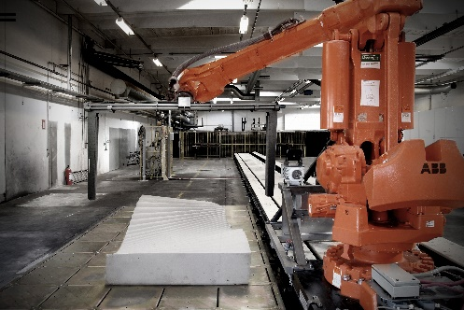
[Figure 21 – Odico hot wire cutting robot (Image Credit: Odico Formwork Robotics)]

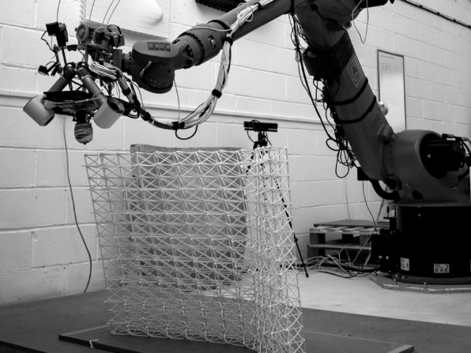
[Figure 22 – AiBuild 3dprint general robotic printing (Image Credit: AiBuild)]

They are a leading industry partner in 3D printing. So, we do these kinds of industry collaborations with industry partners to kind of understand what is their technology and how we can use it in design. So, it’s kind of a both ways, they are also pursuing some aspects they want to push, and we are kind of pushing our design exploration.

44:53 HL: With the industry partners, they usually have a small research outset or a shared value system in that they're trying to explore something that is at the innovative end of the spectrum. And Odico, recently gone public company, they are doing remote robotics now, onsite foam cutting, but also—I'll show you this in a minute after this one—working with AI build and start up dealing with robotic 3D printing (Figure 23).
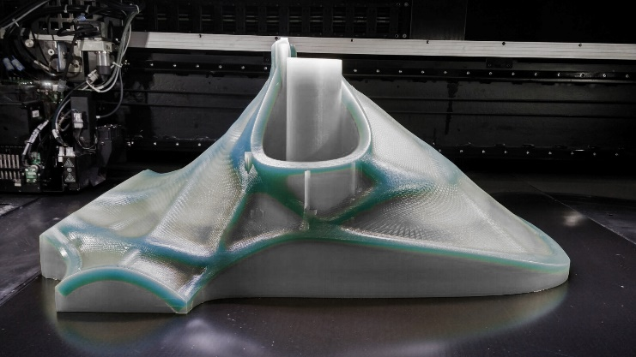
[Figure 23 – Stratasys 3dprinted Chair partial assembly (Image Credit: Stratasys)]

They are sort of like-minded in that they want to explore something, but they may not quite know the solution, right. And they're comfortable in that design space, that's not for everyone, you know, it's like you sort of have to be a little uncomfortable and OK with it, you know, not really know what the solution will be, and our collaborations tend to be this way.

We know we're going somewhere but we may not know exactly what it is. Sometimes that comes down to just how we're interchanging files and sometimes it comes down to actually developing new equipment, new methods, new ways of producing or fabricating. So, they're very much collaborators but they are also —we could not do what we do without them as —research partners. They're part of the research. It’s not like we, they're not just hired on to produce something, like, they are hired on to help up explore the possibilities of something.

And how many chairs were made Vishu?

46:40 This one, we did three or four prototypes at different scales (one is two, one is to one) to try and understand how, what are the different processes of manufacturing and how it can be improved so every prototype was an improvement of the previous one (Figure 24).

VIDEO
[Figure 24 – Stratasys 3dPrinted Chair video (Video Credit: Zaha Hadid Architects)]

HL: Yeah

VB: So, they were also willing to do that, right, so that also comes from the fabricator, or in this case Stratasys, to push the research to understand better how it can be done better.

47:14 MM: And so, the use different scales is to see which one would be more effective or how to do guys use scales in terms of your model-making?

VB: It depends on what we are exploring. So, for example, of the Science Museum one, just because it was a physically handleable scale. But for the chair the different scales was also based on the time we had to print, because printing takes quite a bit of time at the time it was done, in 2014 the first time. And also, it was decided based on the print bed size. So, if you wanted to do it in one shot, one is to two scale which can be done if you have more time and one is to one scale. So also, split/slice up of the geometry, so we had, there was an exhibition coming up in two or three weeks, so they had to split the geometry into twenty different parts and it was all printed in different parts of the world and then it came to the U.S and then it was assembled (Figure 25).

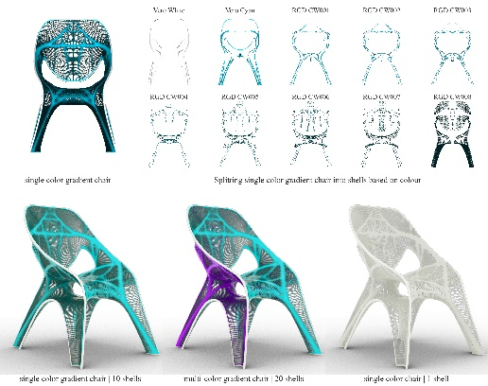
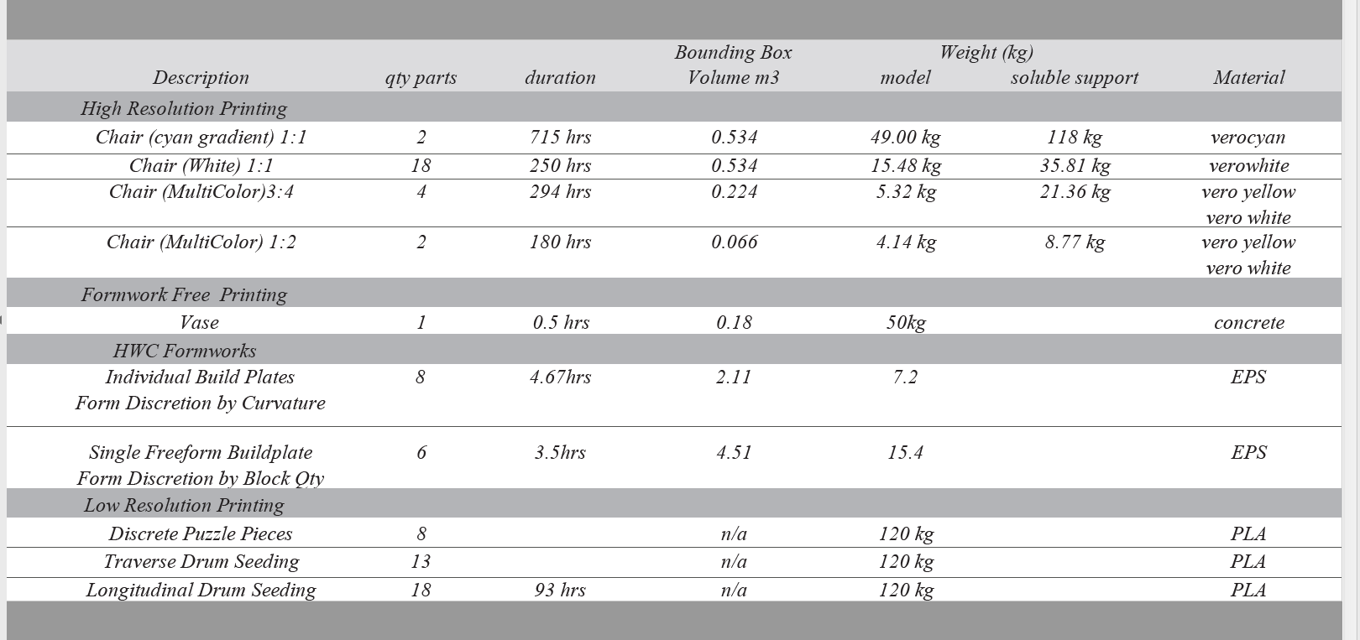
[Figure 25 – Stratasys geometry parts and 3dprinting parts statistics (Image Credit: Zaha Hadid Architects)]

So, there were limitations in splitting that, because the splitting was not considered in the design process. There was a way, difficulties in putting it back together because they were different tolerances because it was printed in different places and that's exactly why we wanted all of these constraints - so if it has to be split into 100 parts or 20 parts or 5 parts, it should be considered at the design stage and that's why we keep telling even to the collaborator, “OK if you want to split it then it needs to be done in a more” - so we would design it in a different way if it has to be split. If it is done in two parts, it will be designed in a different way, so that needs to be considered in the design itself.

49:04 MM: Of course

HL: What's really neat about the number of parts in that sense is that model will always be tied to that particular fabrication and that particular time or the size of the beds. Now if you were to remake it, it would not have as many parts, it would have more because they could be bigger, or because the technology has advanced. So that as a ‘model’ was — its place in time is very specific— and when we look back on things, that's how we use the ‘models’. It’s to think about how their place in time was, how they were relevant for that period. And sometimes it’s not what they look like, but what they're trying to explore. And so, I'm glad that you pointed out the number of parts on that (Stratasys Chair) one because there were so many versions that had different ones because of that.

This one, the scale of this one is very much tied to – so, Thallus was an experimental structure for Milan and it was 3D printed (Figure 26).

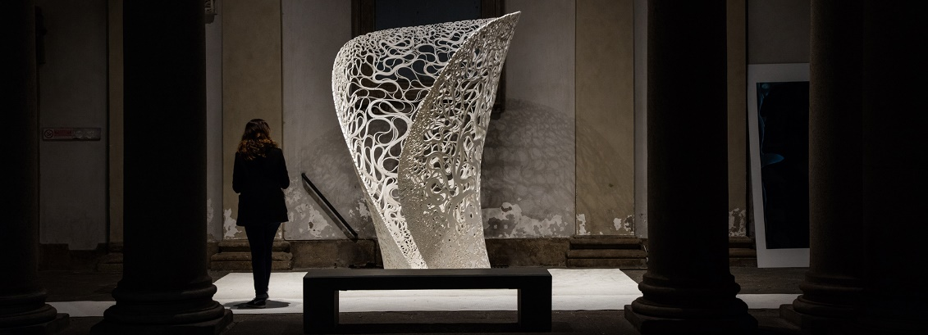
[Figure 26 – Thallus general photo (Image Credit: Luke Hayes)]

It’s about a 7km strand of plastic that has been computed to be this giant sinuous banded structure and the edges are densified to make it sort of structurally relevant there, it’s banded up along the spine to give it additional stiffness and it has a weighted base to keep it because it is so light you could pick it up and walk around with it. And this is, again the size of this one was also tied to the time, robotically. The number of layers on this, we had wanted to be twice as many but because of the time allotted we sort of cut it down. And this was done with a robot, so it was a lower resolution than what Vishu mentioned with Stratasys. And so, our ability to explore this was not just digitally with a pattern, so we made a model that would simulate how we make this pattern (Figure 27, 28, 29), and how we manipulate this pattern for structural purposes. And finally, how we created this pattern in relevant increments that could be printed in a continuous drone.
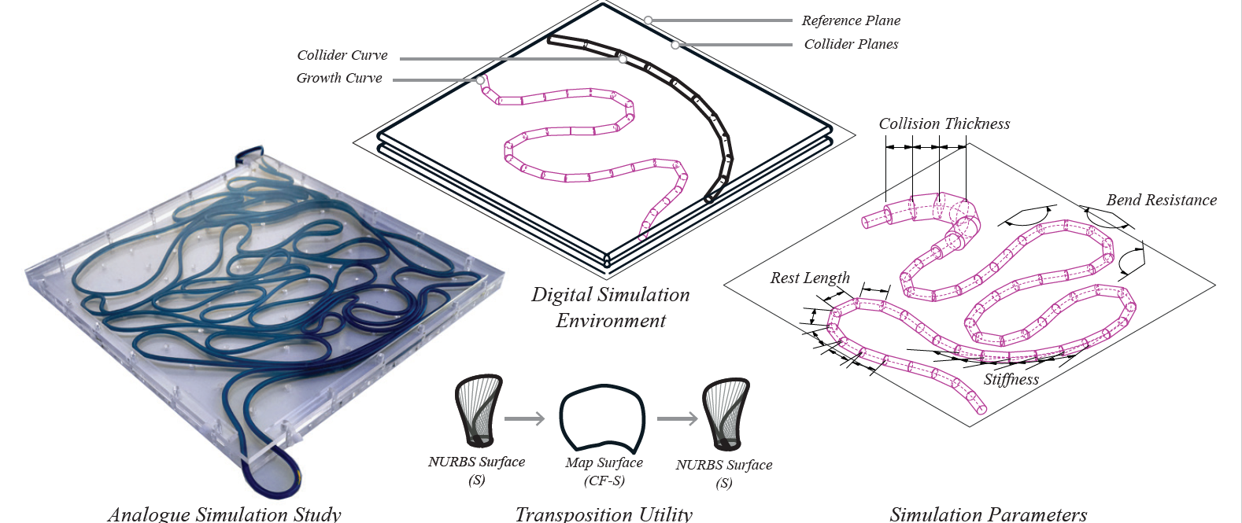

[Figure 27 – Thallus pattern physical simulation model and digital simulation model equivalent (Image Credit: Zaha Hadid Architects)]
[Figure 28 – Thallus digital simulation model seeding parameters (Image Credit: Zaha Hadid Architects)]
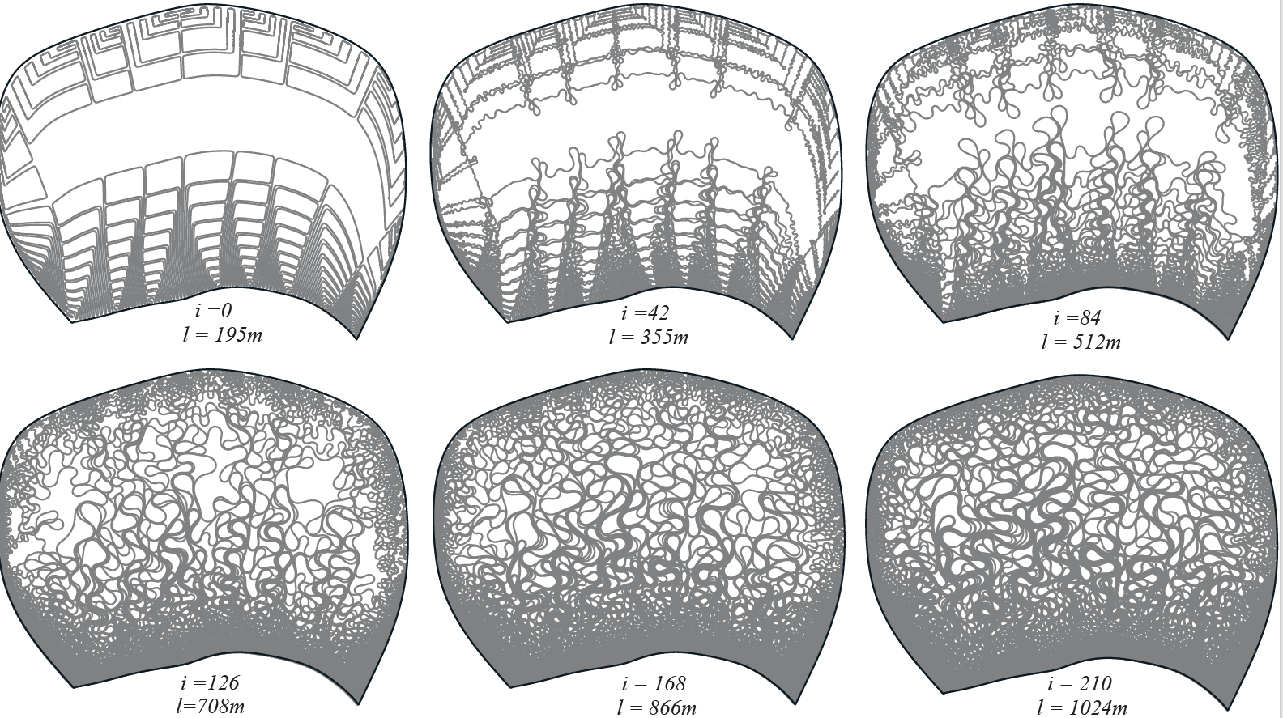
[Figure 29 – Thallus pattern simulation model growth steps (Image Credit: Zaha Hadid Architects)]

So, if you can imagine a typewriter, right, as you type, if you were to print in a way that a type writer would print you would sort of be able to go all the way around the page in one go and this is what we wanted to do. But if you imagine that a giant squiggle line if you tried to trace it and you had no parameters you could just go back and forth, back and forth, back and forth, back and forth, right, which is not ideal for fabrication to continually just sort of spin something in print form (Figure 30).

[Figure 30 – Thallus formwork rotation and parts incrementing diagram (Image Credit: Zaha Hadid Architects)]

So, we have to tie into the fabrication and the size of this thing, the shape of the parts, and the relevance of the robot's reach and these are things which are not immediately evident when you look at it, but if someone would try to reproduce such a thing they would run into. And so, we're trying to develop with AI build and some of their intelligence and robotic printing, this was their first go at printing on a free form mold, until then they'd only sort of printed on flat beds. So, developing ways of registering things, calibrating formwork, these were things they were interested in, they'd never done. They had a very tight time frame to work on. So, some of the intelligence in how they generated toolpaths, so they didn't overly stretch around corners, they're very subtle things. And I'm sure they haven't even told us everything that they developed, but that's what we look for when we collaborate; other people that want to go on this adventure to sort of explore the unexplored. There may be small incremental ‘advancements’, I'm using air quotes here, incremental changes to take the profession in ways which we can build upon and again it’s about incremental building blocks, not just for us but for other people in the profession as well.

53:16 VB: Thallus is a good example also apart from the fabrication things that Henry mentioned, was like how we adapted the design itself. So, in this case we knew it was going to be printed by a robot, so when you're sending it to the robot, it needs to be lines - the robot is anyway going to move in lines so the design exploration itself was; “what can a line be?” So, it is kind of growth of a line, a differential growth of a line to create this structure. So, because it is going to be printed and because the robot needs lines, the design exploration was; “what can we do with the line?” So, if we grow what can we do, and what will be the differential growth and then we started adding onto this, structural constraints of “OK at the edge it needs to be more stiff so there [are] more line or more of this wiggly-ness at the edges and more porous in the centre.” (Figure 31).

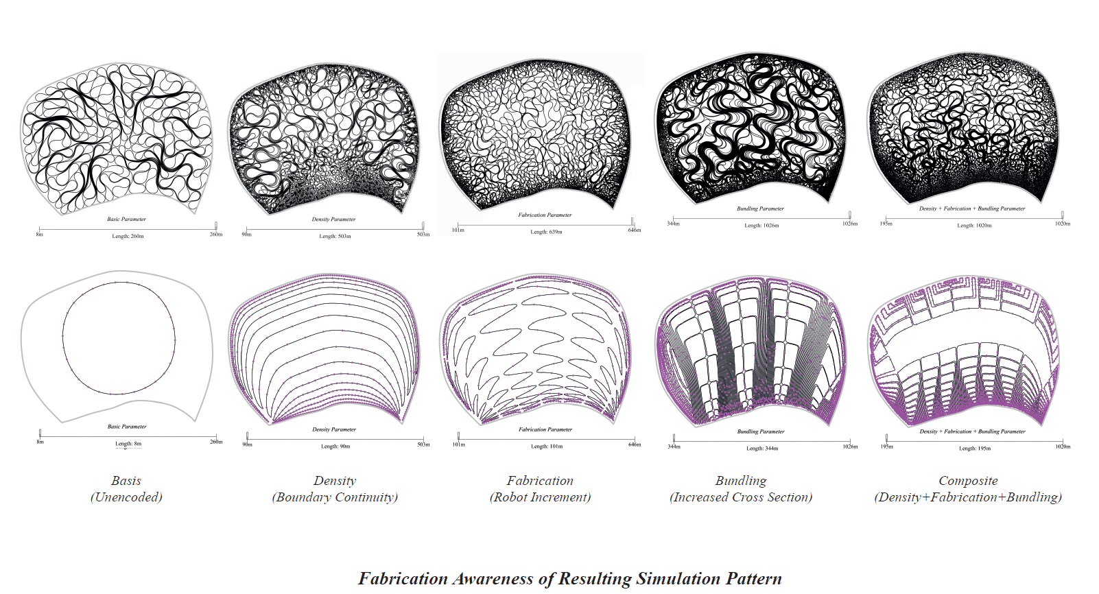
[Figure – 31 Thallus fabrication aware simulation model patterns (Image Credit: Zaha Hadid Architects)]

So, again, that's responding to structure. But again, as I said, like, in this case the design itself was developed based considering that it is going to be printed with a robot. If it was some other fabrication methodology, it would be a different design.

54:25 MM: Right. Thank you. So, maybe we can wrap up with the concept that I think I've taken away from everything you've said, which is that for you the model is really a representation of the now, of the contemporary, and sort of what you can do in this day and age or at this moment in time. Maybe we can talk about a project that is as recent as possible to see how that is developing in, you know, January 2019.

55:01 VB: So, the most recent published project we did was this prototype for the exhibition in Mexico. It opened in October 2018. So, it’s called the Knit Candela (Figure 32).
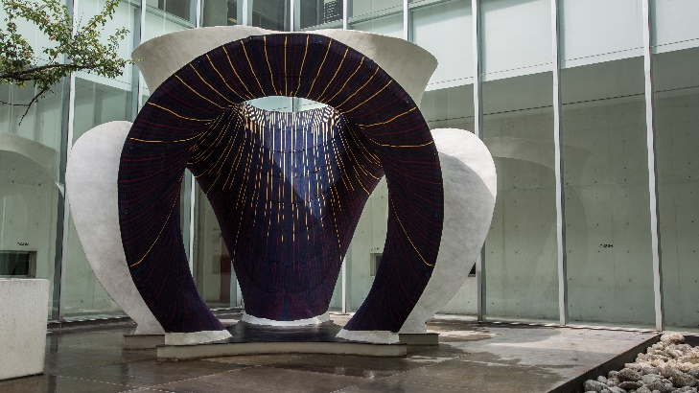

[Figure 32 – Knit Candela General Photo View (Image Credit: Juan Pablo Allegre)]

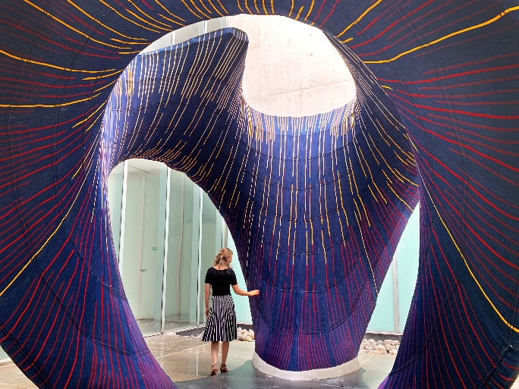
[Figure 32A – Knit Candela General Photo View (Image Credit: Philippe Block – Block Research Group )]

That was exploring, as we said a historic continuum, we are interested in these funicular or shell structures built by Candela a Mexican architect / engineer who built a lot of shell structures in Mexico (Figure 33).
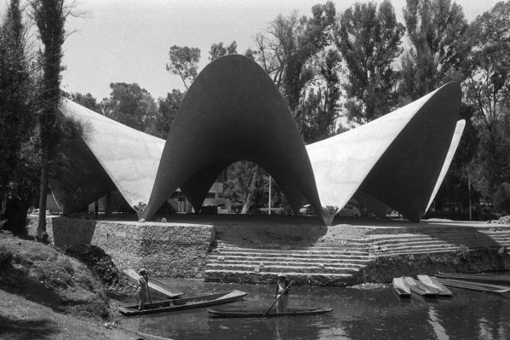

[Figure 33 – Felix Candela Los Manantiales, Mexico City 1958. General shell structure image (Image Credit: Juan Guzmán/Archivo Fundación Televisa)]

55:33 MM: And factories, no? At some point?

55:34 VB: Yes, he did most of them were in a specific group of geometries called hypars. We have done previous investigations into Candela's work and it was previously explored in 2013 for a Beijing Biennale (Figure 34), but in this case we were kind of looking at new technology, which was done in collaboration with a Block Research Group (BRG) and Architecture Extrapolated, so here, so Block Research Group had this research going about doing this knitting of formworks called knitted formworks.
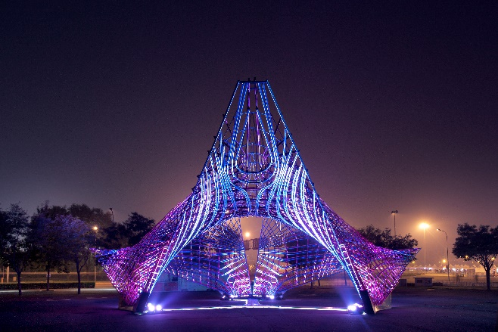
[Figure 34 – ZHA Beijing Candela Revisited general image (Image Credit: Photograph by Xia Zhi)]

When we look at all the construction images of Candelas work you can see, what you see, in the first image you see in most of them is the scaffold required to build that shell (Figure 35).
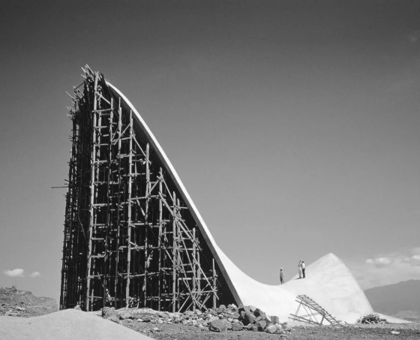
[Figure 35 – Chapel Lomas de Cuernavaca construction by Félix Candela, located in Cuernavaca, Mexico. 1959 Scaffold formworks historic image (Image Credit: Alberto Moreno Guzmán and Antonio Candela, from the archives of FA-UNAM)]

So, in here we were trying to kind of get rid of the scaffold. The knit fabric is the scaffold on which you do the concreting and then once the scaffold, minimal scaffold is removed, the fabric actually stays as part of the structure. So, it's a ‘lost’ formwork, and that was the investigation here. As you can see this video in ETH Zurich; they had this machine that did the knitting and all of this interestingly was also kind of exploring all of the foam work, which was knitted in Switzerland and was taken in two bags to Mexico and then erected there (Figure 36).

VIDEO
[Figure 36 – Knit Candela Overview Video (Video Credit: Block Research Group & Zaha Hadid Architects with Architecture Extrapolated via https://vimeo.com/297258002)]

So, you can see in the video here, the two backpacks going to Mexico. So, this again kind of highlights the benefits of also collaborating. In this case we were collaborating with the Block Research Group who do a lot investigation into equilibrium structures.

MM: Yes.

VB: And then also collaborating with Architecture Extrapolated, who have experience in building in Mexico. Previously we did two concrete shells structures in Mexico in 2013 and 2011 (Figure 37, 38).
So, there was a lot of experience in doing these concrete shells so in this case with those kind of clubbing interests of all these collaborators of fabric, knitting fabric, concrete shells and then our own interest in form finding these shells.
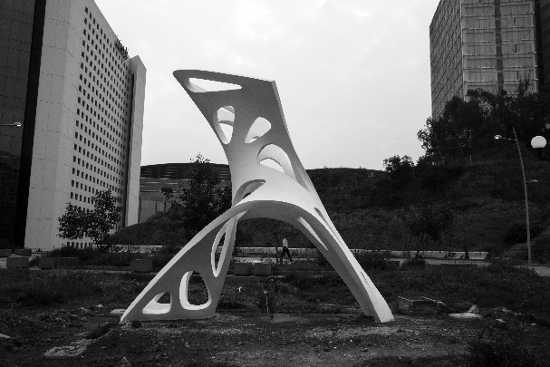
[Figure 37 – ZHA and AA Visiting School Mexico City topology optimised shell structure 2013 (Image Credit: Zaha Hadid Architects)]
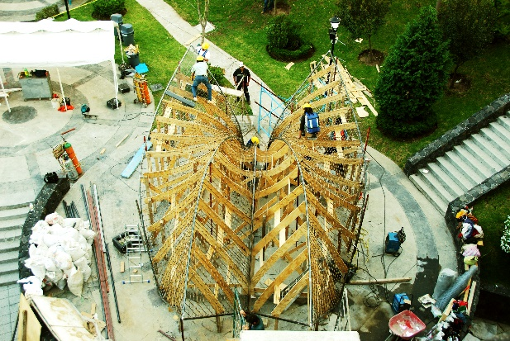
[Figure 38 – ZHA and AA Visiting School Mexico City shell structure 2011 (Image Credit: Zaha Hadid Architects)]

57:55 HL: And this is a demonstration of a number of models that Block Research Group had already started to undertake to explore how to cast a concrete, how to do the junctions – there are individual models to develop the technology and to develop the methods and even sequencing to some extent – a lot of these things before we had gotten to the point where we could do a larger demonstrator installation together. So, this is maybe the first time that all of those individual smaller models and methods now come together as this, including the digital simulations and physical requirements of the space to do such a thing. But the actual tool, the scaffold here is what has really changed fundamentally. If you ask, could Candela have done a fabric form? I don't know that he could have done it as rapidly as we computed this, but certainly the way that it has been constructed has changed, right? Just saying, what are the next possible ways to make things lighter, in keeping with the way that he was constructing.

VB: The interesting thing about this was the time period also. From design to actual completion, it was actually 3 months. So, it started end of June and it opened mid-October so 3, 3 and a half months. Because we had previous collaborations with them, although we didn’t build anything with them, we had been actively in touch with them and developing tools, so we had a workflow already in place so that's why we were able to turn it around so quickly. It's the same with Architecture Extrapolated. We had worked with them previously and because we had this collaborative set-up [from] previous years, it was faster to turn around things within a very small timeframe.

1:00:10 MM: Fantastic. Well, thank you so much. I think it’s been really interesting to hear about particularly your innovation and your kind of philosophy of 'what if?' is what I take away. So, thank you Vishu, thank you Henry for being with us.

